* Copyright for test papers and marking guides remains with *West Australian Test Papers*.
* The papers may only be reproduced within the purchasing school according to the advertised conditions of sale.
* Test papers must be withdrawn after use and stored securely in the school until October 13th.

**HUMAN BIOLOGY**

**Units 3 & 4**

**2022**

**Insert School Logo**

Name: _______________________________________________________

Teacher: ___________________________________________________

**Time allowed for this paper**

Reading time before commencing work: ten minutes

Working time: three hours

**Materials required/recommended for this paper**

***To be provided by the supervisor***

This Question/Answer booklet

Multiple-choice answer sheet

***To be provided by the candidate***

Standard items: pens (blue/black preferred), pencils (including coloured), sharpener, correction fluid/tape, eraser, ruler, highlighters

Special items: up to three calculators, which do not have the capacity to create or store programmes or text, are permitted in this ATAR course examination

**Important note to candidates**

No other items may be taken into the examination room. It is **your** responsibility to ensure that you do not have any unauthorised material. If you have any unauthorised material with you, hand it to the supervisor **before** reading any further.

**Structure of this paper**

|  |  |  |  |  |  |
| --- | --- | --- | --- | --- | --- |
| Section | Number of questions available | Number of questions to be answered | Suggested working time (minutes) | Marks available | Percentage of examination |
| Section One Multiple-choice | 30 | 30 | 40 | 30 | 30 |
| Section Two Short answer | 7 | 7 | 90 | 100 | 50 |
| Section Three Extended answer  Unit 3 | 2 | 1 | 50 | 20 | 10 |
| 20 | 1  100 |
| Unit 4 | 2 | 1 |  | 20 | 10 |
|  |  |  |  | **Total** | 100 |

**Instructions to candidates**

1. The rules for the conduct of the Western Australian examinations are detailed in the *Year 12 Information Handbook 2022: Part II Examinations*. Sitting this examination implies that you agree to abide by these rules.

2. Write your answers in this Question/Answer booklet preferably using a blue/black pen. Do not use erasable or gel pens.

3. Answer the questions according to the following instructions.

Section One: Answer all questions on the separate Multiple-choice answer sheet provided. For each question, shade the box to indicate your answer. Only use a blue or black pen to shade the boxes. Do not use erasable or gel pens. If you make a mistake, place a cross through that square, then shade your new answer. Do not erase or use correction fluid/tape. Marks will not be deducted for incorrect answers. No marks will be given if more than one answer is completed for any question.

Section Two: Write your answers in this Question/Answer booklet. Wherever possible, confine your answers to the line spaces provided.

Section Three: Consists of two parts each with two questions. You must answer one question from each part. Tick the box next to the question you are answering. Write your answers in this Question/Answer booklet.

4. You must be careful to confine your answers to the specific questions asked and to follow any instructions that are specific to a particular question.

5. Supplementary pages for planning/continuing your answers to questions are provided at the end of this Question/Answer booklet. If you use these pages to continue an answer, indicate at the original answer where the answer is continued, i.e. give the page number.

**Section One: Multiple-choice 30% (30 Marks)**

This section has **30** questions. Answer **all** questions on the separate Multiple-choice answer sheet provided. For each question shade the box to indicate your answer. Use only a blue or black pen to shade the boxes. Do not use erasable or gel pens. If you make a mistake, place a cross through that square, then shade your new answer. Do not erase or use correction fluid/tape. Marks will not be deducted for incorrect answers. No marks will be given if more than one answer is completed for any question.

Suggested working time: 40 minutes.

1. Hypothermia can affect people who take part in outdoor activities in winter without wearing suitable clothing. Some people think that alcohol should be given to those who have hypothermia as it makes them feel warmer. Alcohol causes vasodilation. This means that

(a) they would lose heat faster through conduction and evaporation.

(b) more blood would come to the surface so they would be able to gain heat quickly.

(c) radiation would allow more heat to leave the body.

(d) their medulla oblongata would have initiated a negative feedback loop.

2. Which of the following diagrams shows a sensory neuron?

A B C D

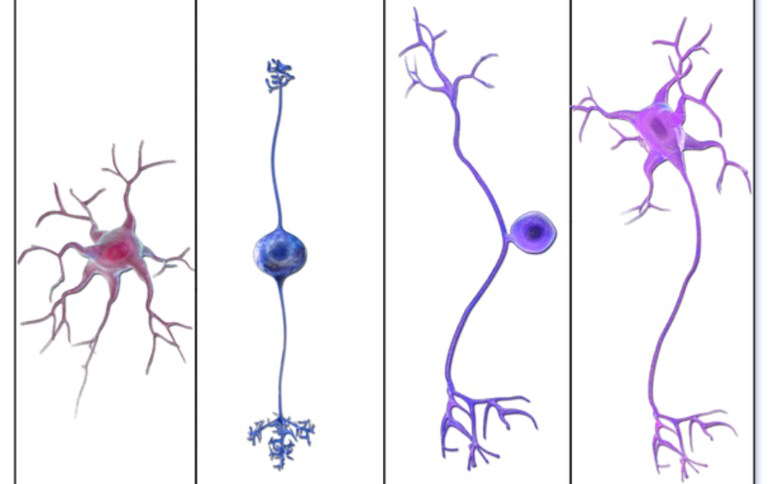

(a) A and D only

(b) B only

(c) C only

(d) B and C only

3. Which of the following is **not** involved in the secondary defence against infection?

(a) stomach acid

(b) mast cells

(c) histamine

(d) phagocytes

4. Scientists compared 250 bases of DNA in the same gene for two different species. They were found to have 1.2% of their bases different. Which of the following is **incorrect**?

(a) The gene used for the comparison could be cytochrome C.

(b) There could be three different amino acids formed as a result of the different bases.

(c) The different bases may not change the amino acids produced by those codons.

(d) Comparing the amino acids would be more accurate than comparing their DNA.

5. Which of the following occur during meiosis and contribute to genetic variation in the offspring?

i) crossing over

ii) gene mutation

iii) random assortment

iv) random fertilisation

(a) i), ii) and iii) only

(b) i) and iii) only

(c) i), ii), iii) and iv)

(d) ii) and iv) only

6. Neuromyelitis optica is an autoimmune disease which results in the destruction of myelin. Which type of lymphocyte would cause this destruction and what would be the effect on the speed of action potential in a neuron affected by neuromyelitis optica?

|  |  |  |
| --- | --- | --- |
|  | **Type of lymphocyte involved** | **Speed of Action Potential** |
| (a) | T cell | Increased |
| (b) | B cell | Decreased |
| (c) | T cell | Decreased |
| (d) | B cell | Increased |

7. The table below shows the number of cases of a particular disease in four different populations. Which population showed the greatest percentage of cases?

|  |  |  |  |
| --- | --- | --- | --- |
|  | **Population** | **Number of cases** | **Size of population** |
| (a) | 1 | 42 | 952,000 |
| (b) | 2 | 18 | 680,300 |
| (c) | 3 | 20 | 683,000 |
| (d) | 4 | 14 | 717,500 |

8. Scientists use both humans and other animals as subjects in their investigations. As part of their investigations, scientists should do all of the following, except one. Which one is **incorrect**?

(a) give human subjects the right to withdraw from the investigation at any time

(b) seek permission from human subjects to use them in the investigation

(c) ensure neither human nor other animal subjects are harmed in the investigation

(d) use as many animals as possible

9. Which combination of features is common to all primates?

(a) similarly sized teeth, arms longer than legs, bipedal stance

(b) binocular vision, hair, transverse and longitudinal arches in the feet

(c) parabolic jaw, tail, nails instead of claws

(d) forward facing eyes, large cranial capacity, opposable thumbs

10. What is the general trend shown by hominin fossils?

(a) The more recent the fossil, the larger the molars and premolars.

(b) The more recent the fossil, the less bowl shaped the pelvis.

(c) The older the fossil, the less parabolic the shape of the jaw.

(d) The older the fossil, the more centrally placed the foramen magnum is.

11. When tissue is damaged, mast cells release histamine. The release of histamine results in

(a) increased vasoconstriction and permeability of blood vessels in the damaged area.

(b) an increase in phagocytes in the damaged area.

(c) the stimulation of T cells.

(d) reduction in blood clotting in the damaged area.

12. Which of the following best shows how the nervous system causes an increase in pupil size?

|  |  |  |
| --- | --- | --- |
|  | **Branch of the nervous system utilised** | **Neurotransmitter released** |
| (a) | Sympathetic | Noradrenalin |
| (b) | Autonomic | Noradrenalin |
| (c) | Parasympathetic | Acetylcholine |
| (d) | Somatic | Acetylcholine |

Question 13 refers to the image below showing types of data and how it can be presented.

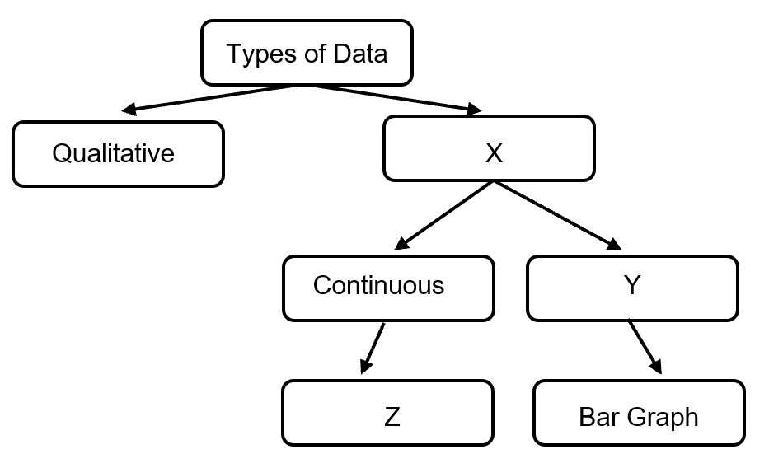

13. Which of the following is correct?

(a) X represents categorical data.

(b) Z is a histogram.

(c) Y is discrete data.

(d) Qualitative data includes measurements.

14. All of the following are advantages of bipedalism, except one. Which one is **incorrect**?

(a) improved teamwork so the group could hunt more successfully

(b) allowed food sources to be seen from a distance

(c) allowed hands free to carry tools and food

(d) reduced exposure to the sun

15. Cooling DNA during the PCR process

(a) separates the double strands of DNA.

(b) allows the restriction enzymes to cut the DNA.

(c) provides an opportunity for the primer to attach to the template strand.

(d) stops the nitrogen bases from attaching to the template strand.

16. Who does not follow the general trend in inferred brain size in hominin evolution?

(a) *Australopithecus afarensis*

(b) *Homo neanderthalensis*

(c) *Homo habilis*

(d) *Homo erectus*

Question 17 refers to the following table which shows the sequence of nitrogen bases for a

portion of the haemoglobin gene for four different species.

|  |  |  |  |  |  |  |
| --- | --- | --- | --- | --- | --- | --- |
| **Species** | **Position 5** | **Position 6** | **Position 7** | **Position 8** | **Position 9** | **Position 10** |
| 1 | G | G | T | A | C | T |
| 2 | G | C | A | A | G | T |
| 3 | G | G | T | T | C | T |
| 4 | G | T | A | A | G | A |

17. The table shows that species

(a) 1 and 2 are most closely related.

(b) 2 and 4 are least closely related.

(c) 2 and 3 are least closely related.

(d) 1 and 3 are most closely related.

Question 18 refers to the image below which shows where a plasmid could be cut by a

number of different restriction enzymes.

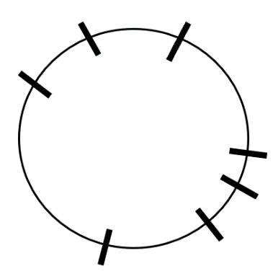 Haelll Kpnl

EcoRI

Sacl

Xbal

Knpl EcoRI

18. A plasmid was mixed with EcoRI, Knpl and Xbal restriction enzymes. Which of the following shows the correct number of restriction sites that would be cut and the number of pieces of plasmid produced?

|  |  |  |
| --- | --- | --- |
|  | **Number of restriction sites that would be cut** | **Number of pieces of plasmid produced** |
| (a) | 3 | 5 |
| (b) | 3 | 4 |
| (c) | 5 | 4 |
| (d) | 5 | 5 |

Question 19 refers to a section of a gene and a mutated version of the same gene.

Normal section of gene G T T A G C C A A T T A C A C T G G A T A G C C

Mutated section of gene G T T A G C C A A T A T C A C T G G A T A G C C

19. This is an example of

(a) a deletion mutation.

(b) an insertion mutation.

(c) an inversion mutation.

(d) a point mutation.

20. There is an increasing trend for bacteria to develop resistance to antibiotics. The implication of this resistance to antibiotics is that

(a) antibiotics will need to be replaced by antiviral drugs.

(b) a person’s immune system will overcome the resistance in the future.

(c) companies will not need to produce any more antibiotics.

(d) different types and strengths of antibiotics will need to be used.

21. A person was lost in the bush during Perth’s record heat wave this past summer. They

(a) would gain heat by evaporation and radiation.

(b) would lose heat by sweating and vasoconstriction.

(c) could minimise their heat gain by spreading out in the shade.

(d) could maximise their heat loss by taking off clothes.

22. Chemoreceptors

(a) for hydrogen ions can be found in the alpha cells of the pancreas.

(b) can detect oxygen, carbon dioxide and glucose.

(c) control the modulator in a negative feedback loop.

(d) and osmoreceptors are found in the hypothalamus.

23. Taq polymerase

(a) is a type of restriction enzyme.

(b) is a heat stable enzyme.

(c) joins the primer to the template strand.

(d) is used in recombinant DNA technology.

24. Which row in the table correctly identifies the characteristics of the somatic and autonomic nervous systems?

|  |  |  |  |  |
| --- | --- | --- | --- | --- |
|  | **Somatic Nervous System** | | **Autonomic Nervous System** | |
|  | Number of neurons in pathway | Neurotransmitter used | Number of neurons in pathway | Neurotransmitter used |
| (a) | 1 | Acetylcholine | 2 | Acetylcholine and Noradrenalin |
| (b) | 2 | Noradrenalin | 1 | Noradrenalin |
| (c) | 1 | Noradrenalin | 2 | Acetylcholine and Noradrenalin |
| (d) | 2 | Acetylcholine | 1 | Noradrenalin |

Question 25 refers to the image of a fossil jaw below.

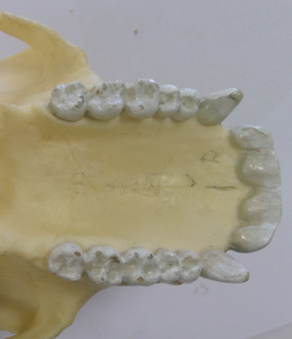

25. This jaw

(a) belongs to a great ape as it has large molars and a diastema.

(b) is from *Australopithecus afarensis* as it has projecting canines.

(c) belongs to *Paranthropus robustus* as it has a U-shaped jaw.

(d) is from an omnivore due to its varied teeth size and shape.

26. Which of the following about thalassemia and Tay Sachs is correct?

(a) Tay Sachs has two different forms that affect populations differently.

(b) The frequency of Tay Sachs in some populations occurs due to sociocultural isolation.

(c) Thalassemia results in a fatty build up in the brain which causes physical deterioration.

(d) Thalassemia offers a heterozygous advantage against tuberculosis.

27. In what order did the cultural advancements of hominins occur?

(a) tools, religion, fire, art

(b) kitchen middens, tools, art, religion

(c) fire, religion, art, kitchen middens

(d) tools, fire, kitchen middens, religion

28. Which of the following would be considered to be a bottleneck event?

(a) A typhoon on Pingelap island reduced the population to 20 individuals.

(b) The Pitcairn island population of 12 was joined by the 9 mutineers from the Bounty.

(c) Dutch people moved from Holland to South Africa to live.

(d) The Silk Road opened up, linking China to Europe.

29. Fossils

(a) require quick burial and an acidic condition to be formed.

(b) must have soft parts and a long period of stability in order to be made.

(c) can be mummified by freezing or drying, or be covered in amber or tar.

(d) can only be found if they have been buried in alkaline soil.

30. An index fossil and correlation of rock strata

(a) are both absolute dating methods.

(b) rely on the principle of superposition to date a specimen.

(c) can only be used at the one archaeological site.

(d) would not be affected by geological disturbances.

**End of Section One**

**Section Two: Short answer 50% (100 Marks)**

This section has **seven** questions. Answer **all** questions. Write your answers in the spaces provided.

Supplementary pages for planning/continuing your answers to questions are provided at the end of this Question/Answer booklet. If you use these pages to continue an answer, indicate at the original answer where the answer is continued, i.e. give the page number.

Suggested working time: 90 minutes.

**Question 31 (20 marks)**

(a) Complete the table below for each of the following scenarios by placing the letter (A, B, or C) in the correct box to show the type of immunity it demonstrates. (3 marks)

A Catching tetanus from a rusty nail

B A one month old does not suffer from the cold her mother has

C Being given an injection after being bitten by a snake

|  |  |  |
| --- | --- | --- |
| **Type of Immunity** | **Natural Immunity** | **Artificial Immunity** |
| **Active Immunity** |  |  |
| **Passive Immunity** |  |  |

(b) Genes isolated from DNA can be used in gene therapy to treat conditions like cystic fibrosis. Healthy individuals have a gene that codes for a channel protein found in the cell membrane of many body cells, including those lining the trachea. People suffering from cystic fibrosis do not have a functioning gene, so their cells do not form these channel proteins.

(i) The treatment of cystic fibrosis is described as a somatic gene therapy. Another type of gene therapy is known as a germ-line therapy. State **two** differences between somatic gene therapy and germ-line therapy. (4 marks)

______________________________________________________________

______________________________________________________________

______________________________________________________________

______________________________________________________________

**Question 31** (continued)

(ii) A student suggested his elderly grandmother, who suffers from Alzheimer’s, could be treated with gene therapy. His friend suggested she should be treated with cell replacement therapy. Explain who is correct. (3 marks)

______________________________________________________________

______________________________________________________________

______________________________________________________________

______________________________________________________________

______________________________________________________________

______________________________________________________________

(c) Two children were given an injection. They were then tested each day to determine the levels of antibodies in their blood. Their results are shown below.

|  |  |  |
| --- | --- | --- |
| Time (days) | Levels of antibodies in the blood (kAU) | |
| Child 1 | Child 2 |
| 0 | 5 | 5 |
| 1 | 20 | 190 |
| 3 | 100 | 170 |
| 5 | 150 | 130 |
| 9 | 90 | 30 |
| 14 | 60 | 10 |
| 15 | 50 | 3 |

(i) Graph this data to show how the antibody level changed over time for each child. (A spare grid can be found at the end of this booklet). (5 marks)



(ii) What was contained in the injection given to Child 2? (1 mark)

______________________________________________________________

(iii) Explain the immunological response of Child 1 if they came into contact with the same antigen that caused this response, in the future. (2 marks)

______________________________________________________________

______________________________________________________________

______________________________________________________________

(iv) State **two** ways in which antibodies can act against an antigen. (2 marks)

______________________________________________________________

______________________________________________________________

______________________________________________________________

**Question 32 (16 marks)**

People who suffer from Type I and Type II diabetes are encouraged to consume food with a

low glycaemic index (GI). The glycaemic index rates food from 0 to 100, indicating how quickly

it increases blood glucose concentrations.

To determine the GI of a biscuit, scientists asked 5 people to fast overnight. The next morning,

each person consumed one biscuit and blood samples were taken every 15 minutes for 2

hours in order to determine their blood glucose concentration. The mean value of all subjects

was used to determine the GI for that food.

(a) Why were all subjects asked to fast overnight? (2 marks)

__________________________________________________________________________

__________________________________________________________________________

__________________________________________________________________________

(b) For the GI calculation to be valid, a number of variables must be controlled. Suggest **two** variables that must have been controlled. (2 marks)

__________________________________________________________________________

__________________________________________________________________________

(c) The mean value of all subjects was used to calculate the GI of the biscuit. Explain why the mean value for all subjects was used and suggest one limitation of this method.

(2 marks)

__________________________________________________________________________

__________________________________________________________________________

__________________________________________________________________________

__________________________________________________________________________

(d) How could the determination of the GI of the biscuit be made more reliable?

(1 mark)

__________________________________________________________________________

__________________________________________________________________________

Older people can develop a condition called Type II diabetes, where they have high blood glucose levels, even though they produce normal amounts of insulin.

(e) Explain why these people have high blood glucose levels, even though they may produce normal amounts of insulin. (1 mark)

__________________________________________________________________________

(f) Suggest **two** symptoms a person would experience if they suffered from Type II diabetes. (2 marks)

__________________________________________________________________________

__________________________________________________________________________

(g) Suggest **two** changes a person suffering from Type II diabetes could make in order to better manage their blood glucose levels. (2 marks)

__________________________________________________________________________

__________________________________________________________________________

__________________________________________________________________________

(h) Insulin targets the liver. What other main tissue type does insulin target? (1 mark)

__________________________________________________________________________

(i) Name the process that occurs in the liver as a result of insulin being present. (1 mark)

__________________________________________________________________________

(j) State the effect of adrenalin on blood glucose levels and explain why this is required at times. (2 marks)

__________________________________________________________________________

__________________________________________________________________________

__________________________________________________________________________

**Question 33 (9 marks)**

The flowchart below shows the endocrine glands and hormones involved in altering the rate of metabolism in a healthy person.

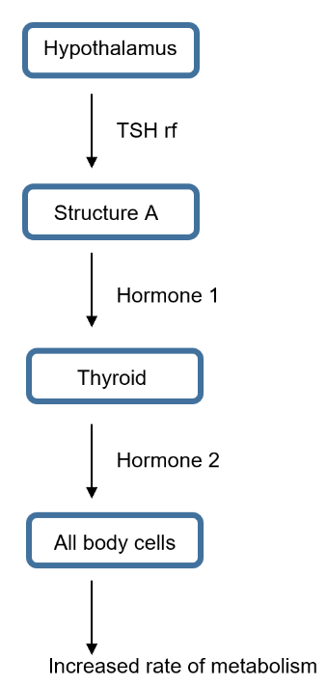

(a) Name Structure A and describe how TSHrf travels to it. (2 marks)

__________________________________________________________________________

__________________________________________________________________________

(b) Explain why Hormone 1 only affects the thyroid while Hormone 2 can affect all body cells. (2 marks)

__________________________________________________________________________

__________________________________________________________________________

__________________________________________________________________________

(c) In order for Hormone 2 to be produced, it requires a substance in the diet. What is the name of this substance? (1 mark)

__________________________________________________________________________

(d) Julie was not feeling well and had been losing weight, so she went to her doctor. He gave her a radioactive substance and scanned her thyroid before comparing her result to that of a healthy person. The results are shown below.



Healthy Person Julie

(i) What condition is Julie suffering from? (1 mark)

______________________________________________________________

(ii) Other than weight loss, name **two** symptoms Julie may be experiencing. (2 marks)

______________________________________________________________

______________________________________________________________

(iii) The doctor suggested an operation to remove part of her thyroid. Explain why this would be an appropriate treatment for Julie’s condition. (1 mark)

______________________________________________________________

______________________________________________________________

**Question 34 (16 marks)**

(a) Explain why the pH of blood can decrease. (3 marks)

__________________________________________________________________________

__________________________________________________________________________

__________________________________________________________________________

__________________________________________________________________________

(b) Low pH reduces the affinity for oxygen to bind to haemoglobin in people with sickle cell trait and they suffer a sickle crisis. State **two** symptoms of someone with a sickle crisis. (2 marks)

__________________________________________________________________________

__________________________________________________________________________

(c) Sickle cell anaemia is the result of a mutation and can be passed on to offspring.

(i) What is a mutation? (1 mark)

______________________________________________________________

______________________________________________________________

(ii) Explain whether the sickle cell mutation is a gene or chromosomal mutation. (2 marks)

______________________________________________________________

______________________________________________________________

______________________________________________________________

(d) A gel electrophoresis was conducted for three members of a family.

(i) Describe the role of the electrical current in gel electrophoresis. (2 marks)

______________________________________________________________

______________________________________________________________

______________________________________________________________

______________________________________________________________

Gel electrophoresis was carried out for the family to determine whether or not any of

them had the sickle cell allele. Their results are shown below.

**Negative Positive**

Mum

Child 1

Child 2

Dad

(ii) Given Child 2 has sickle cell anaemia, complete Dad’s lane in the image above. (1 mark)

(e) Discuss how and provide reasons why the frequency of the sickle cell allele would vary in North America and in Africa. (5 marks)

__________________________________________________________________________

__________________________________________________________________________

__________________________________________________________________________

__________________________________________________________________________

__________________________________________________________________________

__________________________________________________________________________

__________________________________________________________________________

__________________________________________________________________________

**Question 35 (17 marks)**

Recently, a mining giant funded an archaeological excavation at the Yirra rock shelter near Paraburdoo in the Pilbara of Western Australia, where they retrieved stone tools, charcoal and bone. Six individuals were identified, 4 adults and 2 children. The fossils were dated at 50,000 years. Mitochondrial DNA testing determined that three of the adults and both children were related to each other.

(a) Explain how these specimens could have been dated. (5 marks)

__________________________________________________________________________

__________________________________________________________________________

__________________________________________________________________________

__________________________________________________________________________

__________________________________________________________________________

__________________________________________________________________________

__________________________________________________________________________

__________________________________________________________________________

__________________________________________________________________________

__________________________________________________________________________

__________________________________________________________________________

(b) Mitochondrial DNA was used to determine the relatedness of the individuals found in the rock shelter. Explain one advantage and one disadvantage of using mitochondrial DNA rather than nuclear DNA. (3 marks)

__________________________________________________________________________

__________________________________________________________________________

__________________________________________________________________________

__________________________________________________________________________

__________________________________________________________________________

(c) At another site in Europe, scientists determined their specimens belonged to *Homo neanderthalensis*. State **one** anatomical and **two** cultural differences that existed between *Homo neanderthalensis* and *Homo sapiens* (Cro magnon). (6 marks)

|  |  |  |
| --- | --- | --- |
|  | ***Homo neanderthalensis*** | ***Homo sapiens* (Cro Magnon)** |
| **Anatomical** |  |  |
| **Cultural** |  |  |
|  |  |

(d) Two tools, excavated from different archaeological sites, were compared. Tool A was found attached to a portion of a stick while Tool B was not. (These images are not to scale).

Tool A Tool B

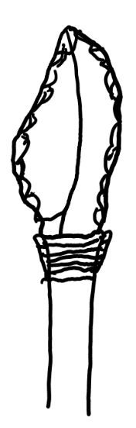 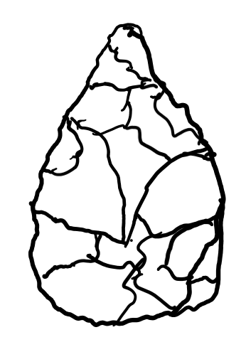

(i) What is the method of attaching tools to wood called? (1 mark)

_____________________________________________________________

(ii) Which hominin would have produced Tool B? (1 mark)

______________________________________________________________

(iii) Which tool, Tool A or Tool B, would have been produced first? (1 mark)

______________________________________________________________

**Question 36 (14 marks)**

(a) Describe one way that both the nervous and endocrine systems can affect breathing rate and explain why being able to use both these systems is an advantage. (6 marks)

__________________________________________________________________________

__________________________________________________________________________

__________________________________________________________________________

__________________________________________________________________________

__________________________________________________________________________

__________________________________________________________________________

__________________________________________________________________________

__________________________________________________________________________

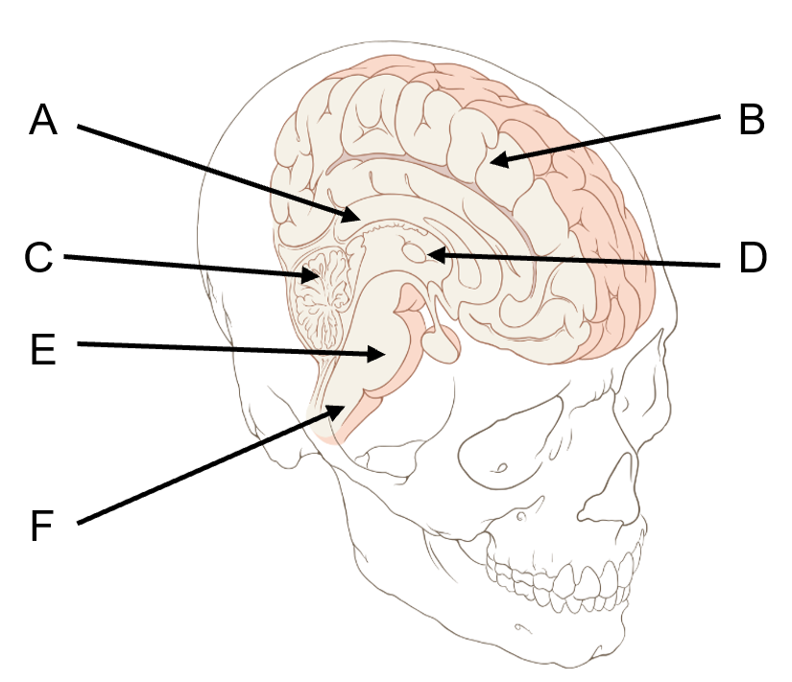

G

(b) Name structure A. (1 mark)

__________________________________________________________________________

(c) Explain how damage to structure G could result in less cortisol being produced. (2 marks)

__________________________________________________________________________

__________________________________________________________________________

(d) Which structure/s shown on the image above would be involved in playing the violin? (2 marks)

__________________________________________________________________________

__________________________________________________________________________

(e) Which structure/s shown on the image on the previous page would be involved in smelling dinner cooking and remembering what it was? (1 mark)

__________________________________________________________________________

__________________________________________________________________________

(f) Describe how the spinal cord is protected from injury. (2 marks)

__________________________________________________________________________

__________________________________________________________________________

__________________________________________________________________________

__________________________________________________________________________

**Question 37 (8 marks)**

The graph below represents the voltage across the membrane of an axon and the changes that take place during the generation and transmission of an action potential.

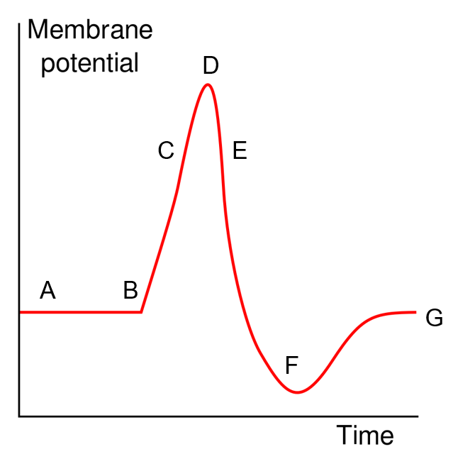

(a) Use the letters A to G to state when each of the following events are occurring. A letter may be used once, more than once or not at all. (4 marks)

|  |  |
| --- | --- |
| **Event** | **Letter/s** |
| Voltage gated potassium channels are open |  |
| Depolarisation |  |
| Potassium ions are actively moved into the neuron |  |
| Sodium potassium pumps are operating |  |

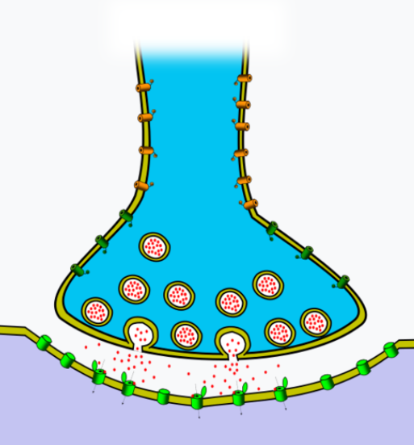

(b) The image above shows the mechanism by which an action potential crosses a synapse. Describe how this process and the release of oxytocin are similar. (4 marks)

__________________________________________________________________________

__________________________________________________________________________

__________________________________________________________________________

__________________________________________________________________________

__________________________________________________________________________

__________________________________________________________________________

**End of Section Two**

**Section Three: Extended answer 20% (40 Marks)**

This section contains **four** questions. You must answer **two** questions.

Questions 38 and 39 are from Unit 3. Questions 40 and 41 are from Unit 4. Answer **one** question from Unit 3 and **one** question from Unit 4.

Responses could include clearly labelled diagrams with explanatory notes; lists of points with linking sentences; clearly labelled tables and graphs; and annotated flow diagrams with introductory notes.

Supplementary pages for planning/continuing your answers to questions are provided at the end of this Question/Answer booklet. If you use these pages to continue an answer, indicate at the original answer where the answer is continued, i.e. give the page number.

Suggested working time: 50 minutes

_________________________________________________________________________

**Unit 3**

Choose **either** Question 38 **or** Question 39.

Indicate the question you will answer by ticking the box next to the question. Write your answer on pages 27-31. When you have answered your first question, turn to page 32 and indicate on that page the second question you will answer.

**Question 38 (20 marks)**

Vaccines were first developed by Edward Jenner in 1796 when he observed that milk maids who milked cows suffered from a mild cowpox but did not suffer from the severe smallpox disease. In order to protect a young boy from the dangerous smallpox disease, Jenner scratched the boy’s skin with the mild cowpox disease.

(a) Compare and contrast the different types of attenuated vaccines and give an example of each type. (8 marks)

(b) The formation of subunit vaccines requires the use of recombinant DNA technology. Describe in detail how a subunit vaccine could be produced and briefly explain why it is not possible for people receiving a subunit vaccine to actually suffer from the disease due to the vaccination itself. (12 marks)

**Question 39 (20 marks)**

John was in need of a kidney transplant. Doctors tested his family members for the possibility of one of them being a living donor.

(a) Describe the immune response John would have to a new kidney if no immunosuppressants were provided. (10 marks)

(b) The kidney is a target for both aldosterone and antidiuretic hormone. Differentiate between the modes of action of these two hormones. (10 marks)

Question number: ________________

__________________________________________________________________________________________________________________________________________________

_________________________________________________________________________

_________________________________________________________________________

_________________________________________________________________________

_________________________________________________________________________

__________________________________________________________________________________________________________________________________________________

_________________________________________________________________________

_________________________________________________________________________

_________________________________________________________________________

_________________________________________________________________________

__________________________________________________________________________________________________________________________________________________

_________________________________________________________________________

_________________________________________________________________________

_________________________________________________________________________

_________________________________________________________________________

__________________________________________________________________________________________________________________________________________________

_________________________________________________________________________

_________________________________________________________________________

_________________________________________________________________________

_________________________________________________________________________

__________________________________________________________________________________________________________________________________________________

Question number: ________________

__________________________________________________________________________________________________________________________________________________

_________________________________________________________________________

_________________________________________________________________________

_________________________________________________________________________

_________________________________________________________________________

__________________________________________________________________________________________________________________________________________________

_________________________________________________________________________

_________________________________________________________________________

_________________________________________________________________________

_________________________________________________________________________

__________________________________________________________________________________________________________________________________________________

_________________________________________________________________________

_________________________________________________________________________

_________________________________________________________________________

_________________________________________________________________________

__________________________________________________________________________________________________________________________________________________

_________________________________________________________________________

_________________________________________________________________________

_________________________________________________________________________

_________________________________________________________________________

_________________________________________________________________________

_________________________________________________________________________

Question number: ________________

__________________________________________________________________________________________________________________________________________________

_________________________________________________________________________

_________________________________________________________________________

_________________________________________________________________________

_________________________________________________________________________

__________________________________________________________________________________________________________________________________________________

_________________________________________________________________________

_________________________________________________________________________

_________________________________________________________________________

_________________________________________________________________________

__________________________________________________________________________________________________________________________________________________

_________________________________________________________________________

_________________________________________________________________________

_________________________________________________________________________

_________________________________________________________________________

__________________________________________________________________________________________________________________________________________________

_________________________________________________________________________

_________________________________________________________________________

_________________________________________________________________________

_________________________________________________________________________

_________________________________________________________________________

_________________________________________________________________________

Question number: ________________

__________________________________________________________________________________________________________________________________________________

_________________________________________________________________________

_________________________________________________________________________

_________________________________________________________________________

_________________________________________________________________________

__________________________________________________________________________________________________________________________________________________

_________________________________________________________________________

_________________________________________________________________________

_________________________________________________________________________

_________________________________________________________________________

__________________________________________________________________________________________________________________________________________________

_________________________________________________________________________

_________________________________________________________________________

_________________________________________________________________________

_________________________________________________________________________

__________________________________________________________________________________________________________________________________________________

_________________________________________________________________________

_________________________________________________________________________

_________________________________________________________________________

_________________________________________________________________________

_________________________________________________________________________

________________________________________________________________________

Question number: ________________

__________________________________________________________________________________________________________________________________________________

_________________________________________________________________________

_________________________________________________________________________

_________________________________________________________________________

_________________________________________________________________________

__________________________________________________________________________________________________________________________________________________

_________________________________________________________________________

_________________________________________________________________________

_________________________________________________________________________

_________________________________________________________________________

__________________________________________________________________________________________________________________________________________________

_________________________________________________________________________

_________________________________________________________________________

_________________________________________________________________________

_________________________________________________________________________

__________________________________________________________________________________________________________________________________________________

_________________________________________________________________________

_________________________________________________________________________

_________________________________________________________________________

_________________________________________________________________________

_________________________________________________________________________

________________________________________________________________________

**Unit 4**

Choose **either** Question 40 **or** Question 41.

Indicate the question you will answer by ticking the box next to the question. Write your answer on the pages provided.

**Question 40 (20 marks)**

(a) *Australopithecus robustus* and *Australopithecus africanus* were considered to be closely related to each other and derived from a common ancestor, *Australopithecus afarensis.* After careful analysis, *Australopithecus robustus* was reclassified as *Paranthropus robustus*.

Draw and label a phylogenetic tree to show the relationship between these

three species before analysis and describe the key anatomical aspects

of the robust form that might have resulted in the change in classification. (6 marks)

(b) *Homo habilis* was the first hominin specimen considered to be fully upright and bipedal. Describe the characteristics of the pelvis, vertebral column and cranium that allowed this hominin to stand and move in this way. (14 marks)

**Question 41 (20 marks)**

(a) Population A, a large population with gene flow, began with an allele frequency of 50% H and 50% h. Population B, a small, isolated population, also began with an allele frequency of 50% H and 50% h. At the end, Population A had become 52% H and 48% h, while Population B has become 80% H and 20% h.

Explain what processes are occurring in each population that resulted in the final allele frequencies. (10 marks)

(b) Ebola is a virus that caused over 11,000 deaths in West Africa between 2014 and 2016. The DNA of the Ebola virus has a rapid rate of mutation. Since the first outbreak, scientists have been working hard to develop a vaccine against the disease.

1. Outline how DNA sequencing and bioinformatics could be used as part of the development of a vaccine against Ebola. (4 marks)
2. Describe the process of PCR and indicate why it would be useful when developing a vaccine. (6 marks)

**End of questions**

Question number: ________________

__________________________________________________________________________________________________________________________________________________

_________________________________________________________________________

_________________________________________________________________________

_________________________________________________________________________

_________________________________________________________________________

__________________________________________________________________________________________________________________________________________________

_________________________________________________________________________

_________________________________________________________________________

_________________________________________________________________________

_________________________________________________________________________

__________________________________________________________________________________________________________________________________________________

_________________________________________________________________________

_________________________________________________________________________

_________________________________________________________________________

_________________________________________________________________________

_________________________________________________________________________

_________________________________________________________________________

_________________________________________________________________________

_________________________________________________________________________

_________________________________________________________________________

__________________________________________________________________________________________________________________________________________________

_________________________________________________________________________

Question number: ________________

__________________________________________________________________________________________________________________________________________________

_________________________________________________________________________

_________________________________________________________________________

_________________________________________________________________________

_________________________________________________________________________

__________________________________________________________________________________________________________________________________________________

_________________________________________________________________________

_________________________________________________________________________

_________________________________________________________________________

_________________________________________________________________________

__________________________________________________________________________________________________________________________________________________

_________________________________________________________________________

_________________________________________________________________________

_________________________________________________________________________

_________________________________________________________________________

__________________________________________________________________________________________________________________________________________________

_________________________________________________________________________

_________________________________________________________________________

_________________________________________________________________________

__________________________________________________________________________________________________________________________________________________

_________________________________________________________________________

Question number: ________________

__________________________________________________________________________________________________________________________________________________

_________________________________________________________________________

_________________________________________________________________________

_________________________________________________________________________

_________________________________________________________________________

__________________________________________________________________________________________________________________________________________________

_________________________________________________________________________

_________________________________________________________________________

_________________________________________________________________________

_________________________________________________________________________

__________________________________________________________________________________________________________________________________________________

_________________________________________________________________________

_________________________________________________________________________

_________________________________________________________________________

_________________________________________________________________________

__________________________________________________________________________________________________________________________________________________

_________________________________________________________________________

_________________________________________________________________________

_________________________________________________________________________

_________________________________________________________________________

_________________________________________________________________________

_________________________________________________________________________

Question number: ________________

__________________________________________________________________________________________________________________________________________________

_________________________________________________________________________

_________________________________________________________________________

_________________________________________________________________________

_________________________________________________________________________

__________________________________________________________________________________________________________________________________________________

_________________________________________________________________________

_________________________________________________________________________

_________________________________________________________________________

_________________________________________________________________________

__________________________________________________________________________________________________________________________________________________

_________________________________________________________________________

_________________________________________________________________________

_________________________________________________________________________

_________________________________________________________________________

__________________________________________________________________________________________________________________________________________________

_________________________________________________________________________

_________________________________________________________________________

_________________________________________________________________________

_________________________________________________________________________

_________________________________________________________________________

_________________________________________________________________________

Question number: ________________

__________________________________________________________________________________________________________________________________________________

_________________________________________________________________________

_________________________________________________________________________

_________________________________________________________________________

_________________________________________________________________________

__________________________________________________________________________________________________________________________________________________

_________________________________________________________________________

_________________________________________________________________________

_________________________________________________________________________

_________________________________________________________________________

__________________________________________________________________________________________________________________________________________________

_________________________________________________________________________

_________________________________________________________________________

_________________________________________________________________________

_________________________________________________________________________

__________________________________________________________________________________________________________________________________________________

_________________________________________________________________________

_________________________________________________________________________

_________________________________________________________________________

_________________________________________________________________________

_________________________________________________________________________

________________________________________________________________________

Supplementary page

Question number: ________________

__________________________________________________________________________________________________________________________________________________

_________________________________________________________________________

_________________________________________________________________________

_________________________________________________________________________

_________________________________________________________________________

__________________________________________________________________________________________________________________________________________________

_________________________________________________________________________

_________________________________________________________________________

_________________________________________________________________________

_________________________________________________________________________

__________________________________________________________________________________________________________________________________________________

_________________________________________________________________________

_________________________________________________________________________

_________________________________________________________________________

_________________________________________________________________________

__________________________________________________________________________________________________________________________________________________

_________________________________________________________________________

_________________________________________________________________________

_________________________________________________________________________

_________________________________________________________________________

_________________________________________________________________________



**ACKNOWLEDGEMENTS**

Question 2

<https://commons.wikimedia.org/wiki/File:Neuron_Classification.png>

Accessed 5th March 2022

Question 31 c) i)

<https://commons.wikimedia.org/wiki/File:Empty_grey_5_mm_graph_paper.pdf>

Question 36 a)

<https://commons.wikimedia.org/wiki/File:Skull_and_sagittal_brain.svg>

Modified

Accessed 5th March 2022

Question 37 a)

<https://commons.wikimedia.org/wiki/File:Action_potential_basic_shape.svg>

Accessed 5th March 2022

Question 37 b)

<https://commons.wikimedia.org/wiki/File:Synapse_unlabeled.png>

Accessed 5th March 2022

All other images, Author’s own